**ELASTIC IP ADDRESS**

Public IP is dynamic, which will get change once we stop and start the instance, to overcome this problem AWS used Elastic IP which is static in nature.

**INSTANCE CREATED:**

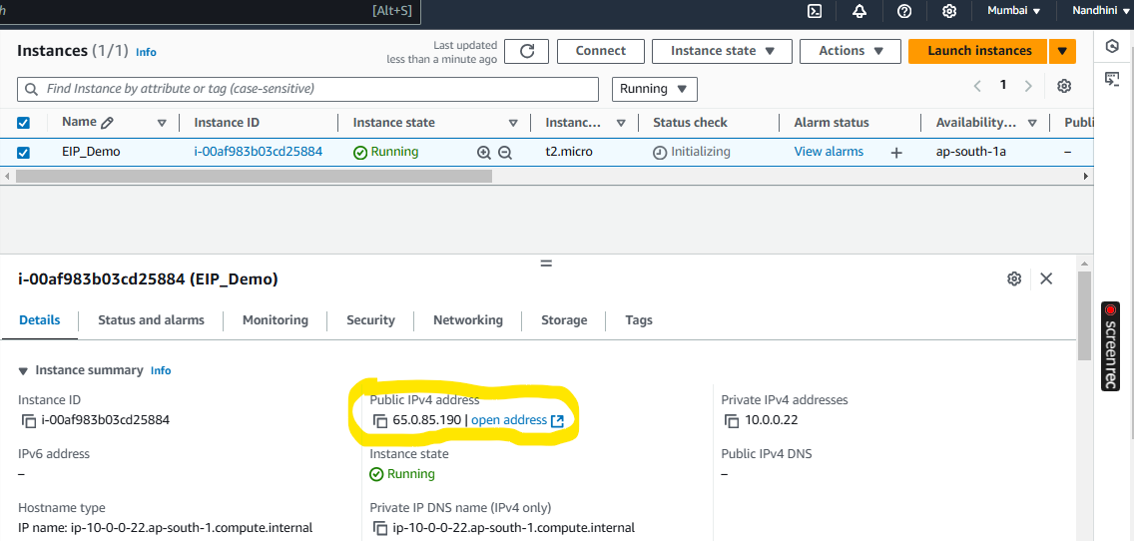

IP Changed after instance stopped and started again:

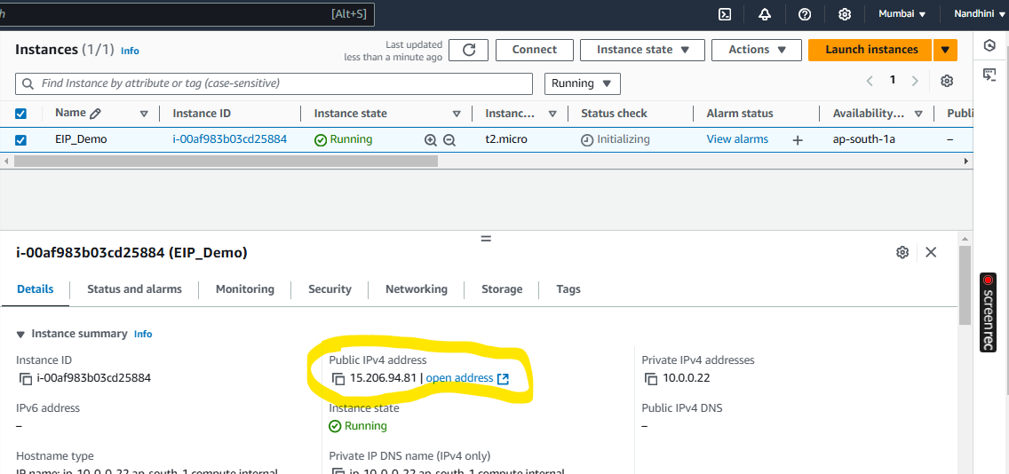

Elastic IP allocated and associated with **running** instance:

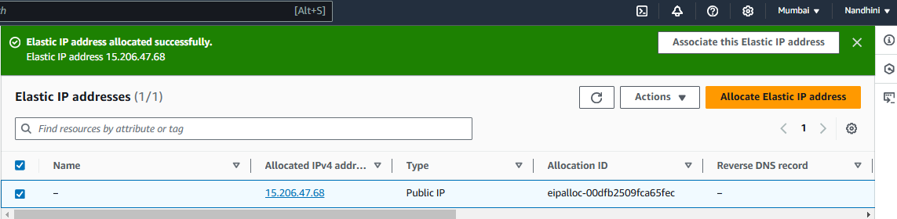

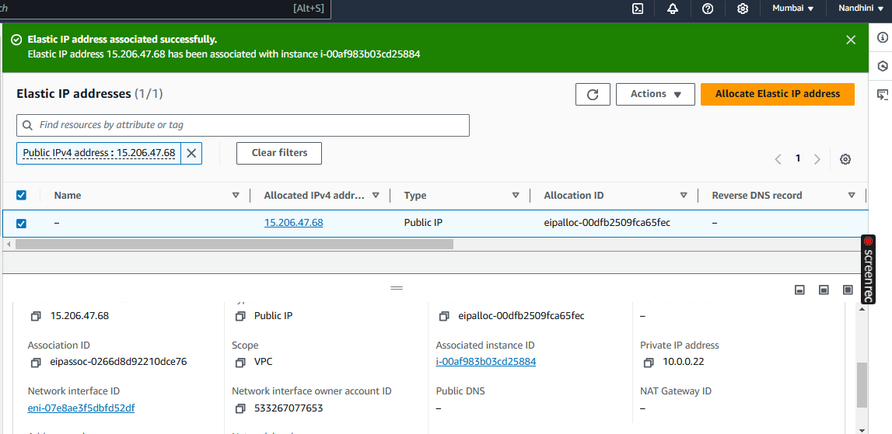

Steps to install Jenkin in Linux Server:

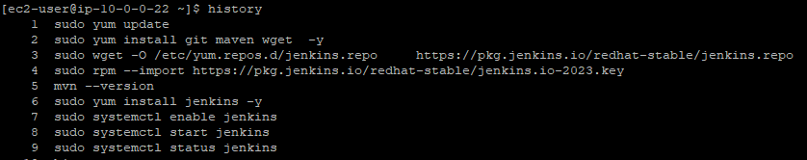

Accessed Jenkin using Elastic IP address:

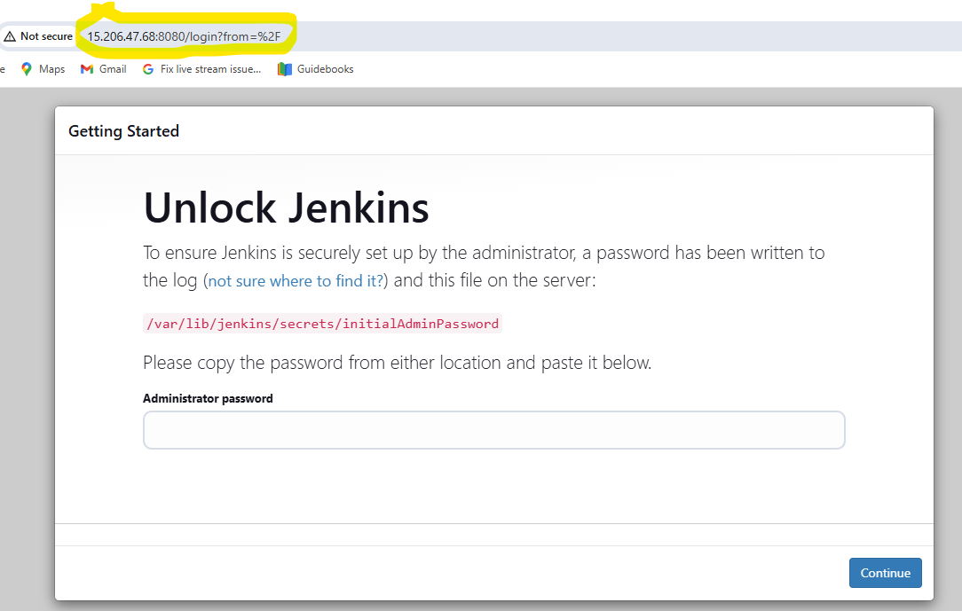

Successfully Disassociated and Released Elastic IP from Instance:

